Valley Christian Fellowship

Senior Pastor Leo Kruger

Associate Pastors: Bill McRae, Rob Simpson, Eddie Sims

Deacons: John Babcock, Joe Doherty and Larry Nolan

Executive Assistant: L.D. McRae
Office Hours: Monday-Friday, noon-5pm
775.265.4100 * valleychristian@hotmail.com

ValleyCF.org for sermons, online giving, and more.

Like us on Facebook at Valley Christian Fellowship/VCF

Our goal is to reach the lost, mature
the saints, worship the Lord,
and be led by the Spirit.

VCF Weekly Schedule

Sun. 10:00am Worship Service
Nursery thru 5th grade classes
Youth Group follows worship
Tues. 6:30pm Men’s Bible Study
Youth Group
Wed. 5:15pm Intercessory Prayer (all welcome)
6:30pm Mid-Week Study
Care for babies thru age 4
Good News Club (grades K-6th)
Thurs. 6:00am Men’s Bible Study
Fri. 6:30am Prayer
Sat. 8:00am Men’s Fellowship Breakfast

Welcome to VCF
If you’re a guest, we’re glad you’re here! Visit our Welcome Desk for info and a gift—our way to say “thanks for checking us out!”

Back to One Service Celebration Lunch
Let’s enjoy some food (loaded super nachos with a hot dog option for kids) and fellowship today after the service. Suggested donation is $3.

Worship Night
Come worship the Lord, Sat., Nov. 6, at 6pm. Babysitting provided.

Sweet Cases Outreach Project
Sat., Nov. 6, 11am-2pm decorate/build a duffel bag (from Together WeRise.org) for a foster care child at Austin’s House. Goal is 10 bags. Lunch provided. See Jen Miller for details. Sign-up at Welcome Desk.

Craft fellowship
(formerly known as Ladies’ Interest Groups)
Tues., Nov. 2, 10am-1pm, Fudge Making with Connie, Tues., Dec. 7, 10am-1pm, Cloth Baskets (good last-minute gifts). Meet at Anni Brown’s (2864 Squires St., Minden).

Healthy Living
(formerly part of Ladies’ Interest Groups)
Thurs., Nov. 11, 10am-1pm, Natural Pain Relief. Meet at Anni Brown’s (2864 Squires St., Minden).

Children’s Ministry
Our need for volunteers continues. Please prayerfully consider serving once a month. Pick up an application at Kidz Check-In.

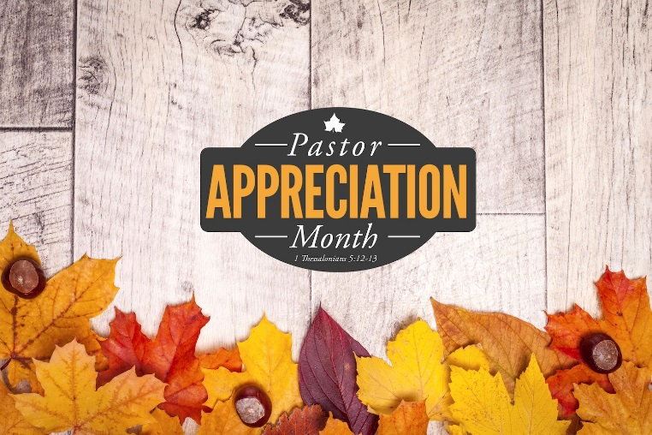

October 24, 2021
C o n n e c t i o n C a r d

Please fill out, tear off, and place in a tithe box at the Welcome Desk so we may better serve you.

Guests: Please fill out your information and prayer requests. We want you to find a church where you can love and be loved. I’ve pastored here 31 years and if VCF is not for you, I know our area pastors and churches and I’d be privileged to help you find a church to suit you. Thanks for worshipping with us and God bless and keep you and your family. Pastor Leo

[ ] New information
[ ] Updated information

Name(s): ________________________________________________________________________________
________________________________________________________________________________________________________________________

[ ] 1st-time guest [ ] 2nd-time guest [ ] Regular attendee

Mailing address:
______________________________________________
___________________________________

Email Address (for VCF updates and Giving Statements):

________________________________________

________________________________________

Telephone(s): ________________________________________________

________________________________________

I found VCF via: [ ] family/friend [ ] website [ ] driving by

I’d like someone to call me: [ ] Yes [ ] No

I’m interested in:

[ ] Committing my life to Christ
[ ] Being water baptized
[ ] Baptism of the Holy Spirit
[ ] Discovering and using my spiritual gifts

Your Prayer Request or Comment:
__________________________________________________________________________________________________________________________________________________________________________________________
___________________________________________________________________________________________________________________________________________________________

R e q u e s t s a r e p r a y e d f o r w e e k l y

Pastor Leo's Office Hours:

Mon. In all day
Tues. In all morning, out for prayer in the afternoon
Wed. In all day
Thur. In all day
Fri. Day off (no calls please)
Sat. Sermon preparation (no calls please)

Connection Opportunities > > >
Connection Groups:

Jerry Howard (Isaiah) Mon., 7:00pm
775.309.7569 Men/Women
Denise Ferrer Tues., 6:30pm
925.413.3844 Women
Bill McRae/Bryan Lowe Tues., 6:30pm
775.781.8971/ 775.857.5729 Men
Jerry Howard (Psalms) Thurs. 6:00am
775.309.7569 Men

Coming Up:

- Oct. 27 No Good News Club Meeting
- Nov. 2 Craft Fellowship - Fudge Making
- Nov. 6 Sweet Cases
- Nov. 12-14 Men’s Encounter
- Nov. 11 Healthy Living – Natural Pain Relief
- Nov. 24 No Good News Club Meeting
- Dec. 7 Craft Fellowship - Cloth Baskets
- Dec. 16 Healthy Living- subject TBA
- Dec. 16 VCF hosts LifeLine Screening
- Dec. 22 No Good News Club Meeting
- Dec. 29 No Good News Club Meeting

PLEASE Keep in Mind:

- Sit with your teen if/when they don’t attend class.
- If children remain in service with you, help yourself to a coloring bag at Kidz Check-In.
- For tithes/offerings: go to ValleyCF.org; text 84321; use debit/credit card; or drop cash/checks in a tithe box in the foyer.
- Smith's donates .5% of all eligible purchases when your rewards link to VCF. Smithsfoodanddrug.com/i/ community/smiths-inspiring-donations.
- Worship Team needs a clear sanctuary for practice.
- Let us know if a member is seriously ill or in hospital.
- FREE video library of studies and kid’s programs at right nowmedia.org/account/invite/valleycf.

